Friends of the Chaska Library Book Sale
Friday, February 21 from 10 am to 5 pm
Saturday, February 22 from 10 am to 3 pm Chaska Library

3 City Hall Plaza, 952-448-3886, www.carverlib.org
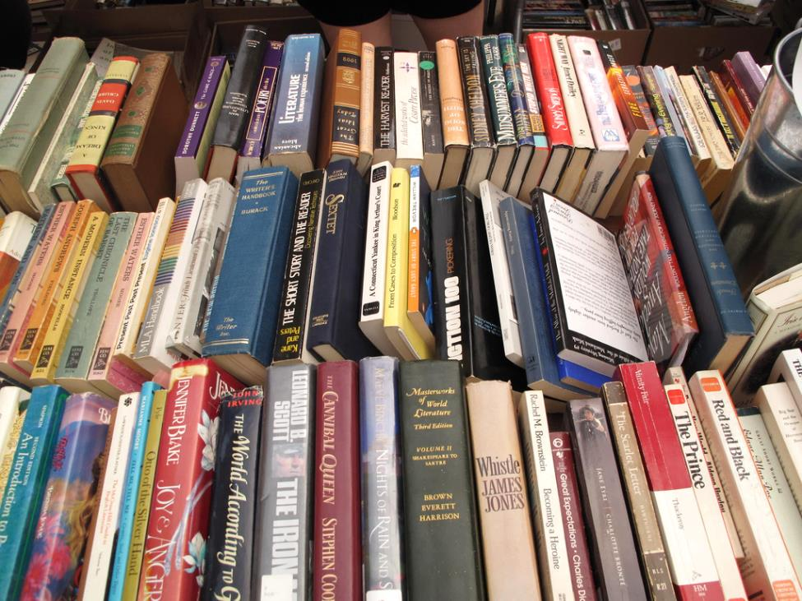

Get good deals on gently used books and more! Includes books for kids, teens, and adults.

